STANDARD EXHIBITS

A COUNTY’S ADMINISTRATION
B CONTRACTOR’S ADMINISTRATION
C CONTRACTOR’S EEO CERTIFICATION
D JURY SERVICE ORDINANCE
E SAFELY SURRENDERED BABY LAW
F SAMPLE WORK ORDER FORMATS
F1 RATE PER MILE BASIS
F2 PRICE PER FIXED ROUTE BASIS
G FORMS REQUIRED FOR EACH WORK ORDER BEFORE WORK BEGINS
UNIQUE EXHIBITS

H Intentionally Omitted
I Intentionally Omitted
J SUBSEQUENT EXECUTED WORK ORDERS
K CHARITABLE CONTRIBUTIONS CERTIFICATION

COUNTY’S ADMINISTRATION

MASTER AGREEMENT NO. _________________ WORK ORDER NO. ________

COUNTY MASTER AGREEMENT PROJECT DIRECTOR (MAPD):

Name: _____________________________

Title: _____________________________
Address:

Telephone: ________________________________

Facsimile: ________________________________

E-Mail Address: ________________________________

COUNTY PROJECT DIRECTOR:

Name: _____________________________

Title: _____________________________
Address:

Telephone: ________________________________

Facsimile: ________________________________

E-Mail Address: ________________________________

COUNTY WORK ORDER DIRECTOR:

Name: _____________________________

Title: _____________________________
Address:

Telephone: ________________________________

Facsimile: ________________________________

E-Mail Address: ________________________________

COUNTY PROJECT MANAGER:

Name: _____________________________

Title: _____________________________
Address:

Telephone: ________________________________

Facsimile: ________________________________

E-Mail Address: ________________________________

CONTRACTOR’S ADMINISTRATION

CONTRACTOR’S NAME

MASTER AGREEMENT NO. _________________ WORK ORDER NO. ________

CONTRACTOR’S PROJECT DIRECTOR:

Name: _____________________________

Title: _____________________________
Address:

Telephone: ________________________________

Facsimile: ________________________________

E-Mail Address: ________________________________

CONTRACTOR’S AUTHORIZED OFFICIAL(S)

Name: _____________________________

Title: _____________________________
Address:

Telephone: ________________________________

Facsimile: ________________________________

E-Mail Address: ________________________________

Name: _____________________________

Title: _____________________________
Address:

Telephone: ________________________________

Facsimile: ________________________________

E-Mail Address: ________________________________

Notices to Contractor shall be sent to the following address:

Name: _____________________________

Title: _____________________________
Address:

Telephone: ________________________________

Facsimile: ________________________________
E-Mail Address: ________________________________

CONTRACTOR'S EEO CERTIFICATION

Contractor Name

Address

Internal Revenue Service Employer Identification Number

GENERAL CERTIFICATION

In accordance with Section 4.32.010 of the Code of the County of Los Angeles, the contractor, supplier, or vendor certifies and agrees that all persons employed by such firm, its affiliates, subsidiaries, or holding companies are and will be treated equally by the firm without regard to or because of race, religion, ancestry, national origin, or sex and in compliance with all anti-discrimination laws of the United States of America and the State of California.

CONTRACTOR'S SPECIFIC CERTIFICATIONS

1. The Contractor has a written policy statement prohibiting Yes No
discrimination in all phases of employment.

2. The Contractor periodically conducts a self-analysis Yes No
or utilization analysis of its work force.

3. The Contractor has a system for determining if Yes No
its employment practices are discriminatory
against protected groups.

4. Where problem areas are identified in employment Yes No
practices, the Contractor has a system for taking
reasonable corrective action, to include
establishment of goals or timetables.

Authorized Official’s Printed Name and Title

Authorized Official’s Signature Date

Page 1 of 3
2.203.010 Findings.
The board of supervisors makes the following findings. The county of Los Angeles allows its permanent, full-time employees unlimited jury service at their regular pay. Unfortunately, many businesses do not offer or are reducing or even eliminating compensation to employees who serve on juries. This creates a potential financial hardship for employees who do not receive their pay when called to jury service, and those employees often seek to be excused from having to serve. Although changes in the court rules make it more difficult to excuse a potential juror on grounds of financial hardship, potential jurors continue to be excused on this basis, especially from longer trials. This reduces the number of potential jurors and increases the burden on those employers, such as the county of Los Angeles, who pay their permanent, full-time employees while on juror duty. For these reasons, the county of Los Angeles has determined that it is appropriate to require that the businesses with which the county contracts possess reasonable jury service policies. (Ord. 2002-0015 § 1 (part), 2002)
2.203.020 Definitions.
The following definitions shall be applicable to this chapter:

A. “Contractor” means a person, partnership, corporation or other entity which has a contract with the county or a subcontract with a county contractor and has received or will receive an aggregate sum of $50,000 or more in any 12-month period under one or more such contracts or subcontracts.

B. “Employee” means any California resident who is a full-time employee of a contractor under the laws of California.

C. “Contract” means any agreement to provide goods to, or perform services for or on behalf of, the county but does not include:

1. A contract where the board finds that special circumstances exist that justify a waiver of the requirements of this chapter; or

2. A contract where federal or state law or a condition of a federal or state program mandates the use of a particular contractor; or

3. A purchase made through a state or federal contract; or

4. A monopoly purchase that is exclusive and proprietary to a specific manufacturer, distributor, or reseller, and must match and inter-member with existing supplies, equipment or systems maintained by the county pursuant to the Los Angeles County Purchasing Policy and Procedures Manual, Section P-3700 or a successor provision; or

5. A revolving fund (petty cash) purchase pursuant to the Los Angeles County Fiscal Manual, Section 4.4.0 or a successor provision; or

6. A purchase card purchase pursuant to the Los Angeles County Purchasing Policy and Procedures Manual, Section P-2810 or a successor provision; or

7. A non-agreement purchase with a value of less than $5,000 pursuant to the Los Angeles County Purchasing Policy and Procedures Manual, Section A-0300 or a successor provision; or

Page 2 of 3

8. A bona fide emergency purchase pursuant to the Los Angeles County Purchasing Policy and Procedures Manual, Section PP-1100 or a successor provision.

D. “Full time” means 40 hours or more worked per week, or a lesser number of hours if:

1. The lesser number is a recognized industry standard as determined by the chief administrative officer, or

2. The contractor has a long-standing practice that defines the lesser number of hours as full time.

E. “County” means the county of Los Angeles or any public entities for which the board of supervisors is the governing body. (Ord. 2002-0040 § 1, 2002: Ord. 2002-0015 § 1 (part), 2002)
2.203.030 Applicability.
This chapter shall apply to contractors who enter into contracts that commence after July 11, 2002. This chapter shall also apply to contractors with existing contracts which are extended into option years that commence after July 11, 2002. Contracts that commence after May 28, 2002, but before July 11, 2002, shall be subject to the provisions of this chapter only if the solicitations for such contracts stated that the chapter would be applicable. (Ord. 2002-0040 § 2, 2002: Ord. 2002-0015 § 1 (part), 2002)
2.203.040 Contractor Jury Service Policy.
A contractor shall have and adhere to a written policy that provides that its employees shall receive from the contractor, on an annual basis, no less than five days of regular pay for actual jury service. The policy may provide that employees deposit any fees received for such jury service with the contractor or that the contractor deduct from the employees’ regular pay the fees received for jury service. (Ord. 2002-0015 § 1 (part), 2002)
2.203.050 Other Provisions.
A. Administration. The chief administrative officer shall be responsible for the administration of this chapter. The chief administrative officer may, with the advice of county counsel, issue interpretations of the provisions of this chapter and shall issue written instructions on the implementation and ongoing administration of this chapter. Such instructions may provide for the delegation of functions to other county departments.

B. Compliance Certification. At the time of seeking a contract, a contractor shall certify to the county that it has and adheres to a policy consistent with this chapter or will have and adhere to such a policy prior to award of the contract. (Ord. 2002-0015 § 1 (part), 2002)
2.203.060 Enforcement and Remedies.
For a contractor’s violation of any provision of this chapter, the county department head responsible for administering the contract may do one or more of the following:

1. Recommend to the board of supervisors the termination of the contract; and/or,

2. Pursuant to chapter 2.202, seek the debarment of the contractor. (Ord. 2002-0015 § 1 (part), 2002)

Page 3 of 3
2.203.070. Exceptions.
A. Other Laws. This chapter shall not be interpreted or applied to any contractor or to any employee in a manner inconsistent with the laws of the United States or California.

B. Collective Bargaining Agreements. This chapter shall be superseded by a collective bargaining agreement that expressly so provides.

C. Small Business. This chapter shall not be applied to any contractor that meets all of the following:

1. Has ten or fewer employees during the contract period; and,

2. Has annual gross revenues in the preceding twelve months which, if added to the annual amount of the contract awarded, are less than $500,000; and,

3. Is not an affiliate or subsidiary of a business dominant in its field of operation.

“Dominant in its field of operation” means having more than ten employees and annual gross revenues in the preceding twelve months which, if added to the annual amount of the contract awarded, exceed $500,000.

“Affiliate or subsidiary of a business dominant in its field of operation” means a business which is at least 20 percent owned by a business dominant in its field of operation, or by partners, officers, directors, majority stockholders, or their equivalent, of a business dominant in that field of operation. (Ord. 2002-0015 § 1 (part), 2002)
2.203.090. Severability.
If any provision of this chapter is found invalid by a court of competent jurisdiction, the remaining provisions shall remain in full force and effect. (Ord. 2002-0015 § 1 (part), 2002)



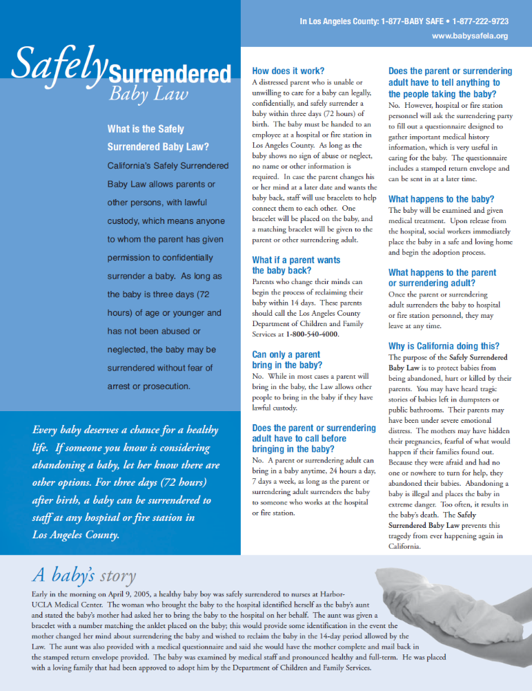

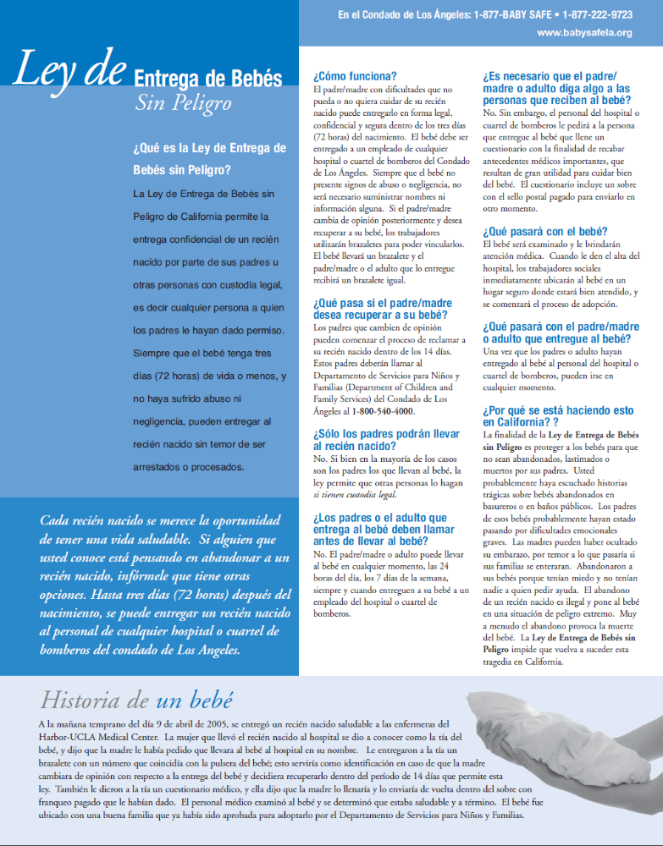

SAMPLE WORK ORDER FORMATS

F1 Rate Per Mile Basis

F2 Price Per Fixed Route Deliverable Basis

A STATEMENT OF WORK SHALL BE ATTACHED TO EACH INDIVIDUAL WORK ORDER

AS-NEEDED TRANSPORTATION SERVICES

MASTER AGREEMENT WORK ORDER
(RATE PER MILE BASIS)

(CONTRACTOR NAME)
Work Order No. County Master Agreement No.

Project Title:

Period of Performance:

County Requesting Department:

County Project Director:

County Manager/Supervisor:

I. GENERAL
Contractor shall satisfactorily perform all Services identified in Section II, Trip Detail, on a rate per mile basis, in compliance with the terms and conditions of Contractor’s Master Agreement identified above.

II. TRIP DETAIL
Contractor shall provide the below-listed personnel and vehicle type whose rate per mile for this trip is as shown:
Rate per mile: @ $____.___/mile.
Vehicle Type:
Operator/Driver Name:

Operator/Driver license number and Class:_________________________________

Pick Up Location Address: ______________________________________________

Drop Off Location Address: _____________________________________________

Total Number of Roundtrip Miles: _________________________________________

III. PAYMENT
A. The Total Maximum Amount that County shall pay Contractor for all Services to be provided under this Work Order shall not exceed ______________________________ ____________________________________ Dollars ($____________).

Work Order No. County Master Agreement No.

B. Contractor shall invoice County only for actually miles driven, in accordance with the terms and conditions of Contractor’s Master Agreement. Contractor shall be responsible for limiting the number of hours worked and miles driven by Contractor Personnel under this Work Order, not to exceed the Total Maximum Amount in III.A, above.
C. Contractor shall satisfactorily perform and complete all required Services in Section II, Trip Detail, notwithstanding the fact that total payment from County shall not exceed the Total Maximum Amount.
D. CONTRACTOR shall submit all invoices under this Work Order to:
________________________

IV. SERVICES
In accordance with Master Agreement Subparagraph 3.3, Contractor may not be paid for any task, service, or other work that is not specified in this Work Order, and/or that utilizes personnel and/or vehicle types not specified in this Work Order, and/or that exceeds the Total Maximum Amount of this Work Order, and/or that goes beyond the expiration date of this Work Order.

ALL TERMS OF THE MASTER AGREEMENT SHALL REMAIN IN FULL FORCE AND EFFECT. THE TERMS OF THE MASTER AGREEMENT SHALL GOVERN AND TAKE PRECEDENCE OVER ANY CONFLICTING TERMS AND/OR CONDITIONS IN THIS WORK ORDER. NEITHER THE RATES NOR ANY OTHER SPECIFICATIONS IN THIS WORK ORDER ARE VALID OR BINDING IF THEY DO NOT COMPLY WITH THE TERMS AND CONDITIONS OF THE MASTER AGREEMENT.

Contractor’s signature on this Work Order document confirms Contractor’s awareness of and agreement with the provisions of Subparagraph 3.3 of the Master Agreement, which establish that Contractor shall not be entitled to any compensation whatsoever for any task, deliverable, service, or other work:
A. That is not specified in this Work Order, and/or
B. That utilizes personnel not specified in this Work Order, and/or
C. That exceeds the Total Maximum Amount of this Work Order, and/or
D. That goes beyond the period of performance of this Work Order.

REGARDLESS OF ANY ORAL PROMISE MADE TO CONTRACTOR BY ANY COUNTY PERSONNEL WHATSOEVER.

CONTRACTOR COUNTY OF LOS ANGELES

By: By:

Name: Name:

Title: Title:

Date: Date:

AS-NEEDED TRANSPORTATION SERVICES

MASTER AGREEMENT WORK ORDER
(PRICE PER FIXED ROUTE BASIS)

(CONTRACTOR NAME)

Work Order No. County Master Agreement No.

Project Title:

Period of Performance:

County Requesting Department:

County Project Director:

County Manager/Supervisor:

I. GENERAL
Contractor shall satisfactorily perform all the tasks and provide all the services detailed in the Statement of Work attached hereto as Attachment 1, on a price per fixed route basis, in compliance with the terms and conditions of Contractor’s Master Agreement.

II. TRIP DETAIL
Price Per Fixed Route: $____.___.
Vehicle Type:
Operator/Driver Name:

Operator/Driver license number and Class: _______________________________________

Pick Up Location Address: ____________________________________________________

Pick Up Location Address: ____________________________________________________

Drop Off Location Address: ___________________________________________________

Total Number of Roundtrip Miles: _______________________________________________

III. A. The Total Maximum Amount that County shall pay Contractor for all Services to be provided under this Work Order shall not exceed __________ Dollars ($____________).
Total Maximum Amount:

Work Order No. County Master Agreement No.

B. Contractor shall satisfactorily perform and complete all required Services in accordance with Attachment 1, Statement of Work, notwithstanding the fact that total payment from County shall not exceed the Total Maximum Amount.

C. Contractor shall submit all invoices under this Work Order to:

________________________

IV. SERVICES
In accordance with Master Agreement Subparagraph 3.3, Contractor may not be paid for any task, service, or other work that is not specified in this Work Order, and/or that utilizes personnel and/or vehicle not specified in this Work Order, and/or that exceeds the Total Maximum Amount of this Work Order, and/or that goes beyond the expiration date of this Work Order.

ALL TERMS OF THE MASTER AGREEMENT SHALL REMAIN IN FULL FORCE AND EFFECT. THE TERMS OF THE MASTER AGREEMENT SHALL GOVERN AND TAKE PRECEDENCE OVER ANY CONFLICTING TERMS AND/OR CONDITIONS IN THIS WORK ORDER. NEITHER THE RATES NOR ANY OTHER SPECIFICATIONS IN THIS WORK ORDER ARE VALID OR BINDING IF THEY DO NOT COMPLY WITH THE TERMS AND CONDITIONS OF THE MASTER AGREEMENT.

Contractor’s signature on this Work Order document confirms Contractor’s awareness of and agreement with the provisions of Subparagraph 3.3 of the Master Agreement, which establish that Contractor shall not be entitled to any compensation whatsoever for any task, deliverable, service, or other work:

A. That is not specified in this Work Order, and/or
B. That utilizes personnel not specified in this Work Order, and/or
C. That exceeds the Total Maximum Amount of this Work Order, and/or
D. That goes beyond the period of performance of this Work Order.

REGARDLESS OF ANY ORAL PROMISE MADE TO CONTRACTOR BY ANY COUNTY PERSONNEL WHATSOEVER.

CONTRACTOR COUNTY OF LOS ANGELES

By: BY:

Name: Name:

Title: Title:

Date: Date:

EXHIBIT G

FORMS REQUIRED FOR EACH WORK ORDER

BEFORE WORK BEGINS

G1 CERTIFICATION OF EMPLOYEE STATUS

G2 CERTIFICATION OF NO CONFLICT OF INTEREST

G3 CONTRACTOR ACKNOWLEDGEMENT AND CONFIDENTIALITY AGREEMENT
OR
G4 CONTRACTOR EMPLOYEE ACKNOWLEDGEMENT AND CONFIDENTIALITY
AGREEMENT

TRANSPORTATION SERVICES

MASTER AGREEMENT WORK ORDER

CERTIFICATION OF EMPLOYEE STATUS

(Note: This certification is to be executed and returned to County with Contractor's executed Work Order. Work cannot begin on the Work Order until County receives this executed document.)

CONTRACTOR NAME

Work Order No. County Master Agreement No.

I CERTIFY THAT: (1) I am an Authorized Official of Contractor; (2) the individual(s) named below is(are) this organization’s employee(s); (3) applicable state and federal income tax, FICA, unemployment insurance premiums, and workers' compensation insurance premiums, in the correct amounts required by state and federal law, will be withheld as appropriate, and paid by Contractor for the individual(s) named below for the entire time period covered by the attached Work Order.
EMPLOYEES

1.

2.

3.

4.

I declare under penalty of perjury that the foregoing is true and correct.

Signature of Authorized Official

Printed Name of Authorized Official

Title of Authorized Official

Date

TRANSPORTATION SERVICES

MASTER AGREEMENT WORK ORDER

CERTIFICATION OF NO CONFLICT OF INTEREST

(Note: This certification is to be executed and returned to County with Contractor's executed Work Order. Work cannot begin on the Work Order until County receives this executed document.)

CONTRACTOR NAME

Work Order No. County Master Agreement No.

Los Angeles County Code Section 2.180.010.A provides as follows:

“Certain contracts prohibited.
A. Notwithstanding any other section of this code, the county shall not contract with, and shall reject any bid or proposal submitted by, the persons or entities specified below, unless the board of supervisors finds that special circumstances exist which justify the approval of such contract:
1. Employees of the county or of public agencies for which the board of supervisors is the governing body;
2. Profit-making firms or businesses in which employees described in subdivision 1 of subsection A serve as officers, principals, partners, or major shareholders;
3. Persons who, within the immediately preceding 12 months, came within the provisions of subdivision 1 of subsection A, and who:
a. Were employed in positions of substantial responsibility in the area of service to be performed by the contract; or
b. Participated in any way in developing the contract or its service specifications; and
4. Profit-making firms or businesses in which the former employees, described in subdivision 3 of subsection A, serve as officers, principals, partners, or major shareholders.”

Contractor hereby declares and certifies that no Contractor Personnel, nor any other person acting on Contractor’s behalf, who prepared and/or participated in the preparation of the bid or proposal submitted for the Work Order specified above, is within the purview of County Code Section 2.180.010.A, above.

I declare under penalty of perjury that the foregoing is true and correct.

Signature of Authorized Official

Printed Name of Authorized Official

Title of Authorized Official

Date
(Note: This certification is to be executed and returned to County with Contractor's executed Work Order. Work cannot begin on the Work Order until County receives this executed document.)

Contractor Name _________________________________________

Work Order No.________________ County Master Agreement No. ______________________

GENERAL INFORMATION:
The Contractor referenced above has entered into a Master Agreement with the County of Los Angeles to provide certain services to the County. The County requires the Corporation to sign this Contractor Acknowledgement and Confidentiality Agreement.

CONTRACTOR ACKNOWLEDGEMENT:
Contractor understands and agrees that the Contractor employees, consultants, Outsourced Vendors and independent contractors (Contractor’s Staff) that will provide services in the above referenced agreement are Contractor’s sole responsibility. Contractor understands and agrees that Contractor’s Staff must rely exclusively upon Contractor for payment of salary and any and all other benefits payable by virtue of Contractor’s Staff’s performance of work under the above-referenced Master Agreement.

Contractor understands and agrees that Contractor’s Staff are not employees of the County of Los Angeles for any purpose whatsoever and that Contractor’s Staff do not have and will not acquire any rights or benefits of any kind from the County of Los Angeles by virtue of my performance of work under the above-referenced Master Agreement. Contractor understands and agrees that Contractor’s Staff will not acquire any rights or benefits from the County of Los Angeles pursuant to any agreement between any person or entity and the County of Los Angeles.

CONFIDENTIALITY AGREEMENT:
Contractor and Contractor’s Staff may be involved with work pertaining to services provided by the County of Los Angeles and, if so, Contractor and Contractor’s Staff may have access to confidential data and information pertaining to persons and/or entities receiving services from the County. In addition, Contractor and Contractor’s Staff may also have access to proprietary information supplied by other vendors doing business with the County of Los Angeles. The County has a legal obligation to protect all such confidential data and information in its possession, especially data and information concerning health, criminal, and welfare recipient records. Contractor and Contractor’s Staff understand that if they are involved in County work, the County must ensure that Contractor and Contractor’s Staff, will protect the confidentiality of such data and information. Consequently, Contractor must sign this Confidentiality Agreement as a condition of work to be provided by Contractor’s Staff for the County.

Contractor and Contractor’s Staff hereby agrees that they will not divulge to any unauthorized person any data or information obtained while performing work pursuant to the above-referenced Master Agreement between Contractor and the County of Los Angeles. Contractor and Contractor’s Staff agree to forward all requests for the release of any data or information received to County’s Project Manager.

Contractor and Contractor’s Staff agree to keep confidential all health, criminal, and welfare recipient records and all data and information pertaining to persons and/or entities receiving services from the County, design concepts, algorithms, programs, formats, documentation, Contractor proprietary information and all other original materials produced, created, or provided to Contractor and Contractor’s Staff under the above-referenced Master Agreement. Contractor and Contractor’s Staff agree to protect these confidential materials against disclosure to other than Contractor or County employees who have a need to know the information. Contractor and Contractor’s Staff agree that if proprietary information supplied by other County vendors is provided to me during this employment, Contractor and Contractor’s Staff shall keep such information confidential.

Contractor and Contractor’s Staff agree to report any and all violations of this agreement by Contractor and Contractor’s Staff and/or by any other person of whom Contractor and Contractor’s Staff become aware.

Contractor and Contractor’s Staff acknowledge that violation of this agreement may subject Contractor and Contractor’s Staff to civil and/or criminal action and that the County of Los Angeles may seek all possible legal redress.

SIGNATURE: DATE: _____/_____/_____

PRINTED NAME: __________________________________________

POSITION: __________________________________________

(Note: This certification is to be executed and returned to County with Contractor's executed Work Order. Work cannot begin on the Work Order until County receives this executed document.)

Contractor Name ________________________________ Employee Name ________________________________________

Work Order No._________________ County Master Agreement No.__________________

GENERAL INFORMATION:
Your employer referenced above has entered into a Master Agreement with the County of Los Angeles to provide certain services to the County. The County requires your signature on this Contractor Employee Acknowledgement and Confidentiality Agreement.

EMPLOYEE ACKNOWLEDGEMENT:
I understand and agree that the Contractor referenced above is my sole employer for purposes of the above-referenced Master Agreement. I understand and agree that I must rely exclusively upon my employer for payment of salary and any and all other benefits payable to me or on my behalf by virtue of my performance of work under the above-referenced Master Agreement.

I understand and agree that I am not an employee of the County of Los Angeles for any purpose whatsoever and that I do not have and will not acquire any rights or benefits of any kind from the County of Los Angeles by virtue of my performance of work under the above-referenced Master Agreement. I understand and agree that I do not have and will not acquire any rights or benefits from the County of Los Angeles pursuant to any agreement between any person or entity and the County of Los Angeles.

I understand and agree that I may be required to undergo a background and security investigation(s). I understand and agree that my continued performance of work under the above-referenced Master Agreement is contingent upon my passing, to the satisfaction of the County, any and all such investigations. I understand and agree that my failure to pass, to the satisfaction of the County, any such investigation shall result in my immediate release from performance under this and/or any future Master Agreement.

CONFIDENTIALITY AGREEMENT:
I may be involved with work pertaining to services provided by the County of Los Angeles and, if so, I may have access to confidential data and information pertaining to persons and/or entities receiving services from the County. In addition, I may also have access to proprietary information supplied by other vendors doing business with the County of Los Angeles. The County has a legal obligation to protect all such confidential data and information in its possession, especially data and information concerning health, criminal, and welfare recipient records. I understand that if I am involved in County work, the County must ensure that I, too, will protect the confidentiality of such data and information. Consequently, I understand that I must sign this agreement as a condition of my work to be provided by my employer for the County. I have read this agreement and have taken due time to consider it prior to signing.

I hereby agree that I will not divulge to any unauthorized person any data or information obtained while performing work pursuant to the above-referenced Master Agreement between my employer and the County of Los Angeles. I agree to forward all requests for the release of any data or information received by me to my immediate supervisor.

I agree to keep confidential all health, criminal, and welfare recipient records and all data and information pertaining to persons and/or entities receiving services from the County, design concepts, algorithms, programs, formats, documentation, Contractor proprietary information and all other original materials produced, created, or provided to or by me under the above-referenced Master Agreement. I agree to protect these confidential materials against disclosure to other than my employer or County employees who have a need to know the information. I agree that if proprietary information supplied by other County vendors is provided to me during this employment, I shall keep such information confidential.

I agree to report to my immediate supervisor any and all violations of this agreement by myself and/or by any other person of whom I become aware. I agree to return all confidential materials to my immediate supervisor upon completion of this Master Agreement or termination of my employment with my employer, whichever occurs first.

SIGNATURE: DATE: _____/_____/_____

PRINTED NAME: __________________________________________

POSITION: __________________________________________

EXHIBIT H

INTENTIONALLY OMITTED

EXHIBIT I

INTENTIONALLY OMITTED

SUBSEQUENT EXECUTED WORK ORDERS

CHARITABLE CONTRIBUTIONS CERTIFICATION

________________________________________________________________________
Company Name

________________________________________________________________________
Address

________________________________________________________________________
Internal Revenue Service Employer Identification Number

________________________________________________________________________
California Registry of Charitable Trusts “CT” number (if applicable)

The Nonprofit Integrity Act (SB 1262, Chapter 919) added requirements to California’s Supervision of Trustees and Fundraisers for Charitable Purposes Act which regulates those receiving and raising charitable contributions.

Check the Certification below that is applicable to your company.

Vendor or Contractor has examined its activities and determined that it does not now receive or raise charitable contributions regulated under California’s Supervision of Trustees and Fundraisers for Charitable Purposes Act. If Vendor engages in activities subjecting it to those laws during the term of a County contract, it will timely comply with them and provide County a copy of its initial registration with the California State Attorney General’s Registry of Charitable Trusts when filed.

OR

Vendor or Contractor is registered with the California Registry of Charitable Trusts under the CT number listed above and is in compliance with its registration and reporting requirements under California law. Attached is a copy of its most recent filing with the Registry of Charitable Trusts as required by Title 11 California Code of Regulations, sections 300-301 and Government Code sections 12585-12586.

___________________________________________ ___________________________
Signature Date

________________________________________________________________________

Name and Title of Signer (please print)

